|  |  |  |
| --- | --- | --- |
| **Assessment Coversheet and Feedback Form** | **Faculty of Computing, Engineering and Built Environment**  School of Computing and Digital Technology | New Logo Tiny |

Complete the details marked in the **coloured text** and leave everything else blank. Where appropriate, copy and paste your submission after the first pages as indicated. You are reminded of the University regulations on cheating. Except where the assessment is group-based, the final piece of work which is submitted must be your own work. Close similarity between submissions is likely to lead to an investigation for cheating. You must submit a file in an MSWord or equivalent format as tutors will use MSWord to provide feedback including, where appropriate, annotations in the text.

|  |  |  |  |
| --- | --- | --- | --- |
| **Student Name** | *Evie Nikolaidou* | **Reasonable Adjustments** |  |
| **Student Number** | S15129366 | Check this box [x] if the Faculty has notified you that you are eligible for a Reasonable Adjustment (including additional time) in relation to the marking of this assessment. Please note that action may be taken under the University’s Student Disciplinary Procedure against any student making a false claim for Reasonable Adjustments. | |
| **Course and Year** | BSc Computer Science, 1st Year |
| **Module Code** | CMP4104 |
| **Module Title** | Software Development UG1 |
| **Module Tutor** |  |
| **Personal Tutor** | Wayne Collymore |

|  |  |  |  |  |  |
| --- | --- | --- | --- | --- | --- |
| **First Marker Name:** |  | **First Marker Signature:** |  | **Date:** |  |
| **Feedback:** General comments on the quality of the work, its successes and where it could be improved | | | | | |
|  | | | | **Provisional Uncapped Mark** Marks will be capped if this was a late submission or resit assessment and may be moderated up or down by the examination board. | |
| % | |
| **Feed Forward:** How to apply the feedback to future submissions | | | | | |
|  | | | | | |

|  |  |  |  |  |  |
| --- | --- | --- | --- | --- | --- |
| **Quality and use of Standard English and Academic Conventions** | | | | | |
|  | Spelling Errors |  | Style is Colloquial |  | **Standard is a Cause for Concern** |
|  | Grammatical Errors |  | Inappropriate Structure | If the box above has been ticked you should arrange a consultation with a member of staff from the Centre for Academic Success via [Success@bcu.ac.uk](mailto:Success@bcu.ac.uk) | |
|  | Punctuation Errors |  | Inadequate Referencing |

|  |  |  |  |  |  |
| --- | --- | --- | --- | --- | --- |
| **Moderation Comments** (Please note that moderation is carried out through ‘sampling’. If this section is left blank, your work is not part of the sample.) | | | | | |
| Moderation is done via sampling. Your work was not part of the sample. | | | | | |
| **Moderator Name:** |  | **Moderator Signature:** |  | **Date:** |  |

Marking Criteria – Please study this page carefully

**Please see the Assessment Briefs for exam and coursework for detail marking criteria. Both assessment briefs are available in the Assessment Section**

|  |  |  |  |  |  |  |
| --- | --- | --- | --- | --- | --- | --- |
|  | **0 – 39%**  **Fail** | **40 – 49%**  **Fail** | **50 – 59%**  **Pass** | **60 – 69%**  **Strong Pass**  **(merit)** | **70 – 79%**  **Very Strong Pass**  **(distinction)** | **80 – 100%**  **Exceptionally Strong Pass**  **(distinction)** |
| Criterion 1  Mark: |  | | | | | |
|  |  |  |  |  |  |
| Criterion 2  Mark: |  | | | | | |
|  |  |  |  |  |  |
| Criterion 3  Mark: |  | | | | | |
|  |  |  |  |  |  |
| Criterion 4  Mark: |  | | | | | |
|  |  |  |  |  |  |

.

|  |  |  |  |  |  |
| --- | --- | --- | --- | --- | --- |
|  | **0 – 39%**  **Fail** | **40 – 49%**  **Pass**  **3rd** | **50 – 59%**  **Pass**  **2:2** | **60 – 69%**  **Pass**  **2:1** | **70 – 100%**  **Pass**  **1st** |
| Criterion 1  Mark: |  | | | | |
|  |  |  |  |  |
| Criterion 2  Mark: |  | | | | |
|  |  |  |  |  |
| Criterion 3  Mark: |  | | | | |
|  |  |  |  |  |
| Criterion 4  Mark: |  | | | | |
|  |  |  |  |  |

Test documentation

First test

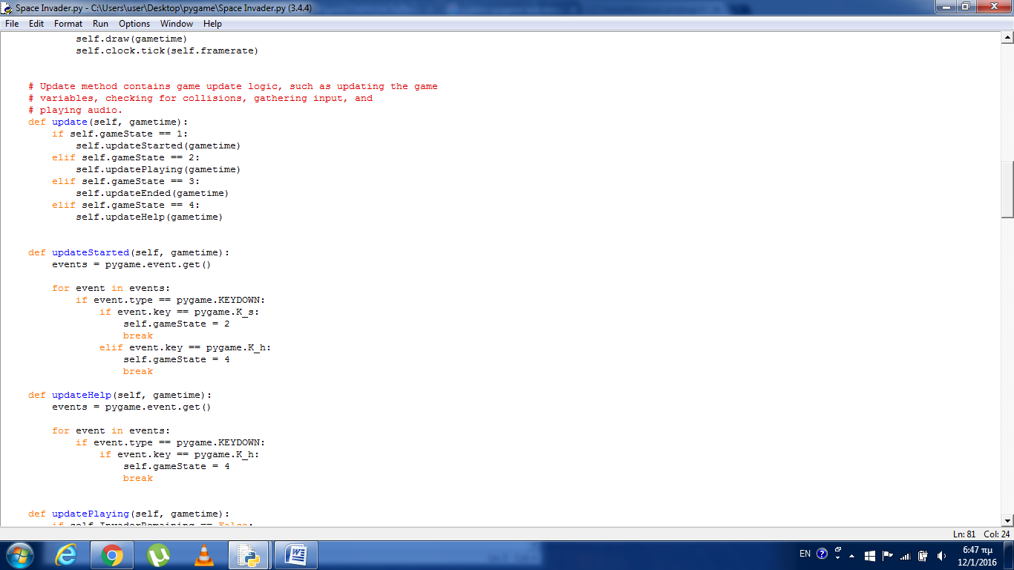

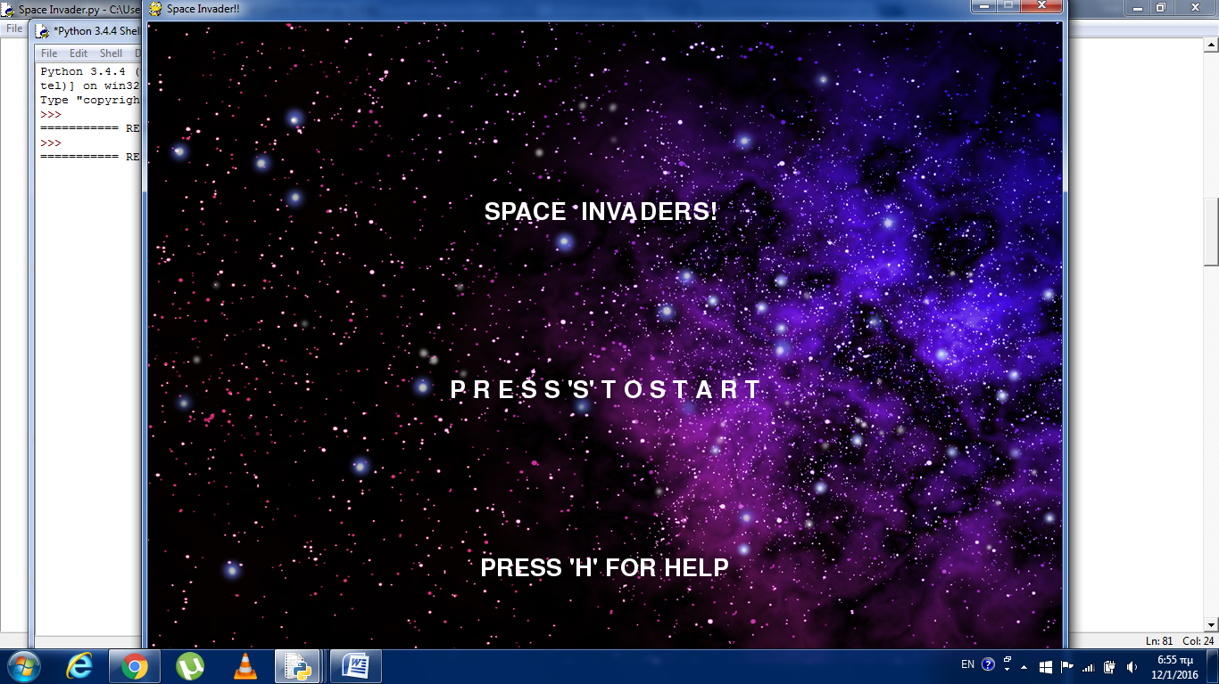

|  |  |  |  |  |
| --- | --- | --- | --- | --- |
| Test Case ID | Game Feature | Input | Expected Output | Observed Output |
| TC-1 | The game is starting | ‘S’ key is pressed | The game is starting | Picture 1 |
| TC-2 | Help menu | ‘H’ key is pressed | Show Help menu | Picture 2 |
|  |  |  |  |  |
|  |  |  |  |  |

With this function the player have a chance to see the help menu but also to start the game

Picture 1 :

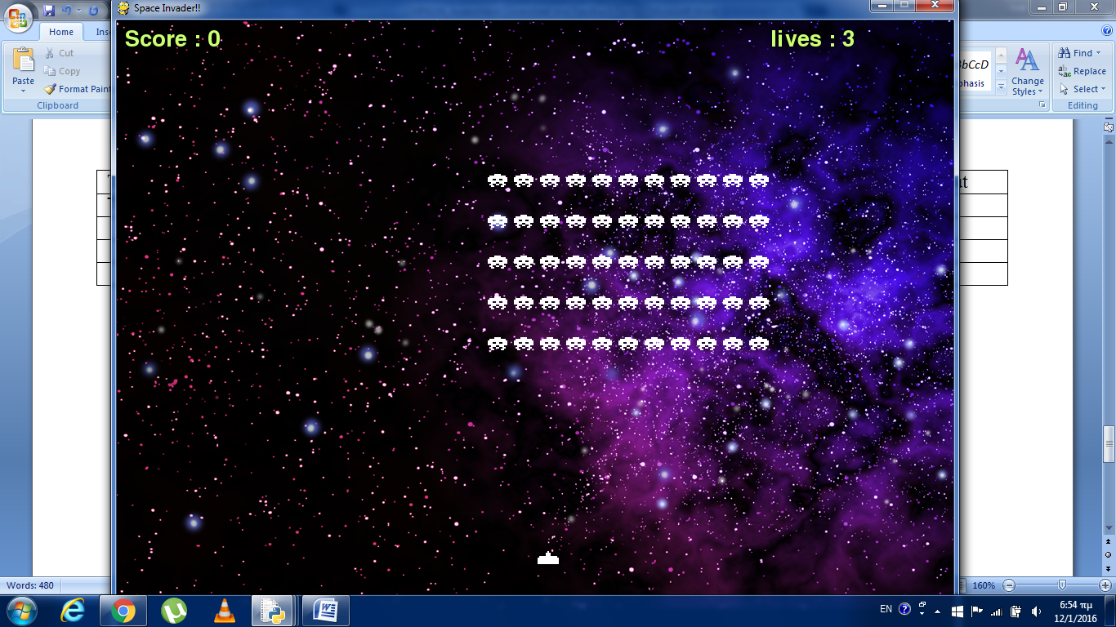

Picture2:

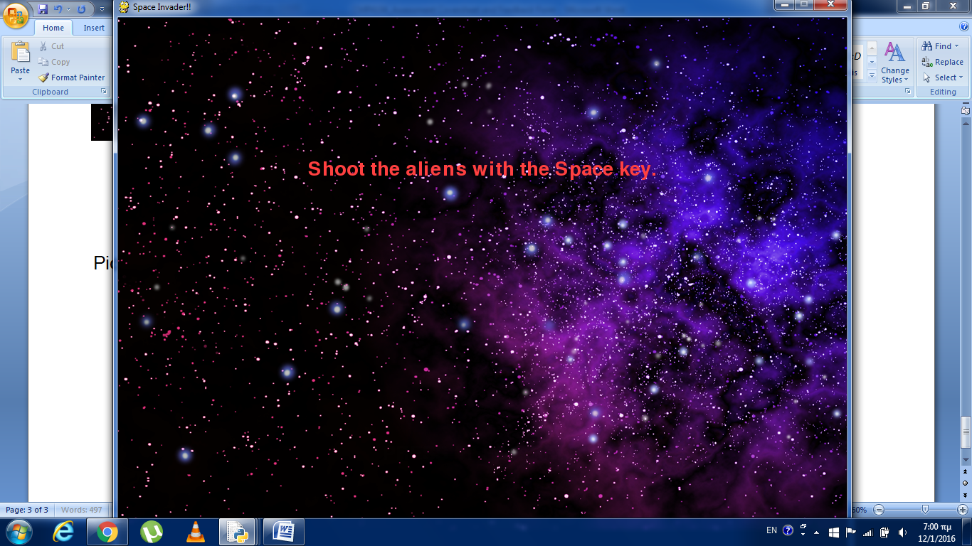

Second Test

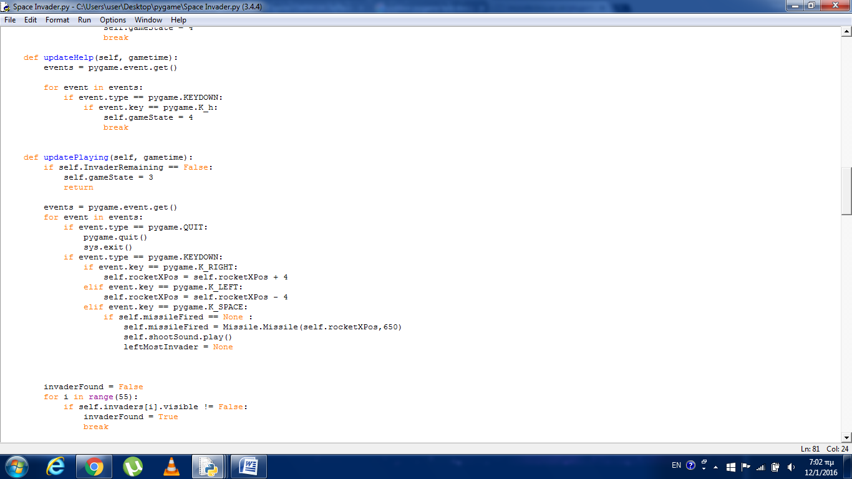

|  |  |  |  |  |
| --- | --- | --- | --- | --- |
| Test Case ID | Game Feature | Input | Expected Output | Observed Output |
| TC-1 | Moving rocket ot the right | right arrow key is pressed | The rocket is moving to the right | Picture 3 |
| TC-2 | Moving rocket ot the left | Left arrow key is pressed | The rocket is moving to the left | Picture 4 |
| TC-3 | Shoot the inventer | Space key is pressed | The rocket is shoting the aliens | Picture 5 |
|  |  |  |  |  |
|  |  |  |  |  |

In this part shows the movements of the rocket and the shooting.

Picture 3

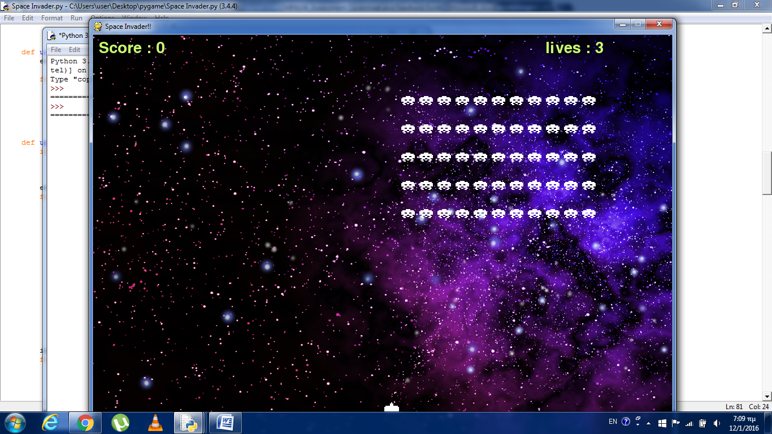

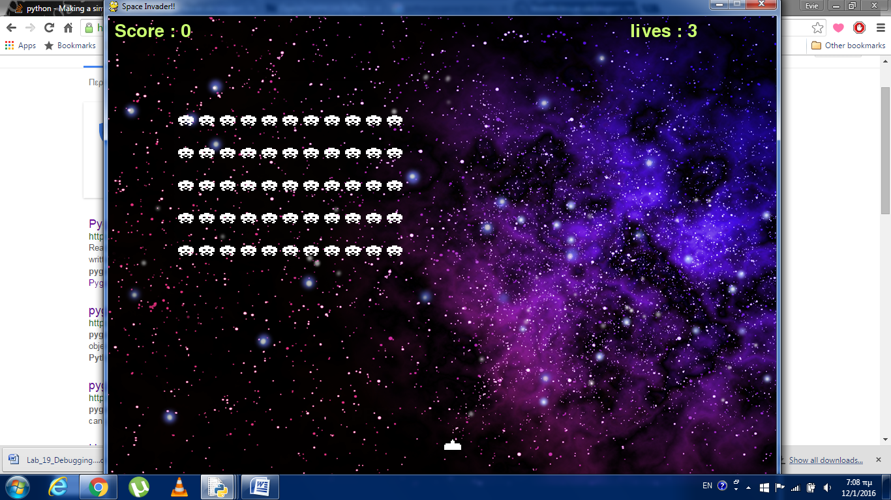Picture 4:

Picture 5:

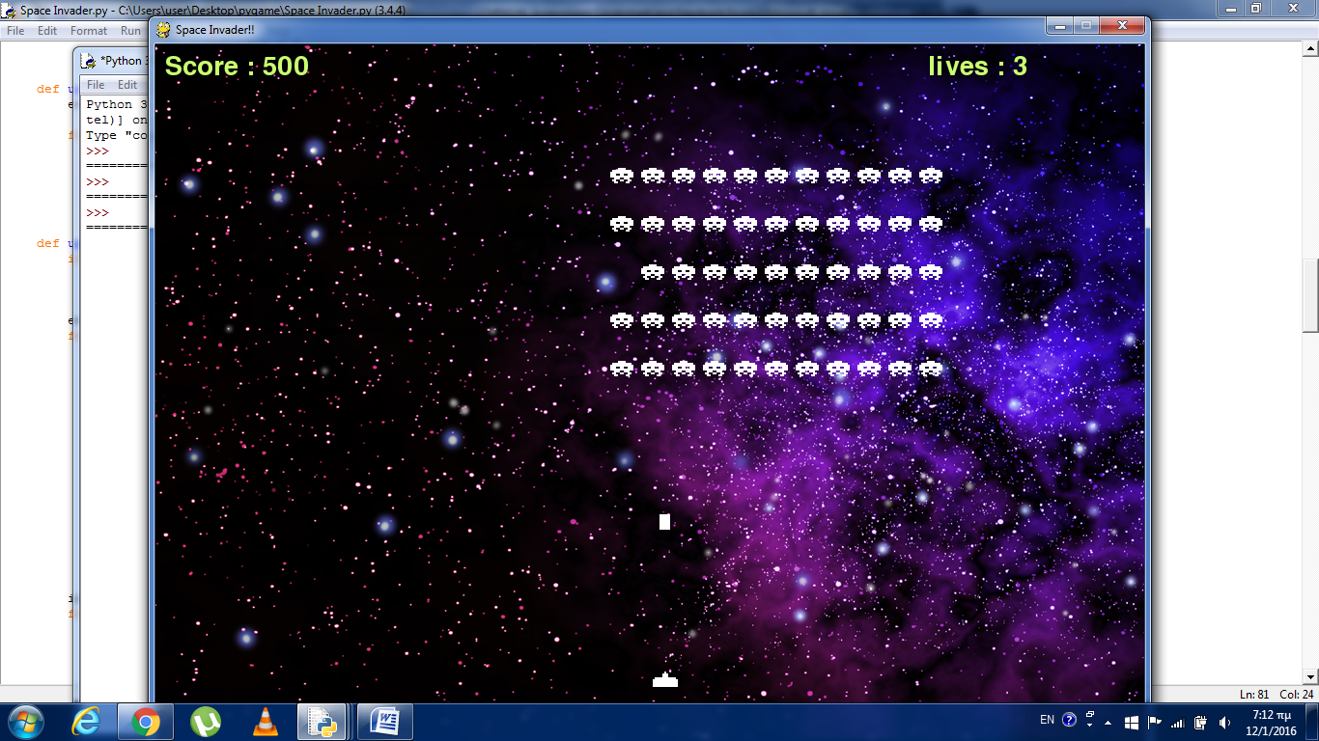

|  |  |  |  |  |
| --- | --- | --- | --- | --- |
| Test Case ID | Game Feature | Input | Expected Output | Observed Output |
| TC-1 | restart | ‘R’ key is pressed | The game is restaring |  |
| TC-2 | Exit game | ‘X’ key is pressed | Exit game |  |
|  |  |  |  |  |
|  |  |  |  |  |

Fourth Test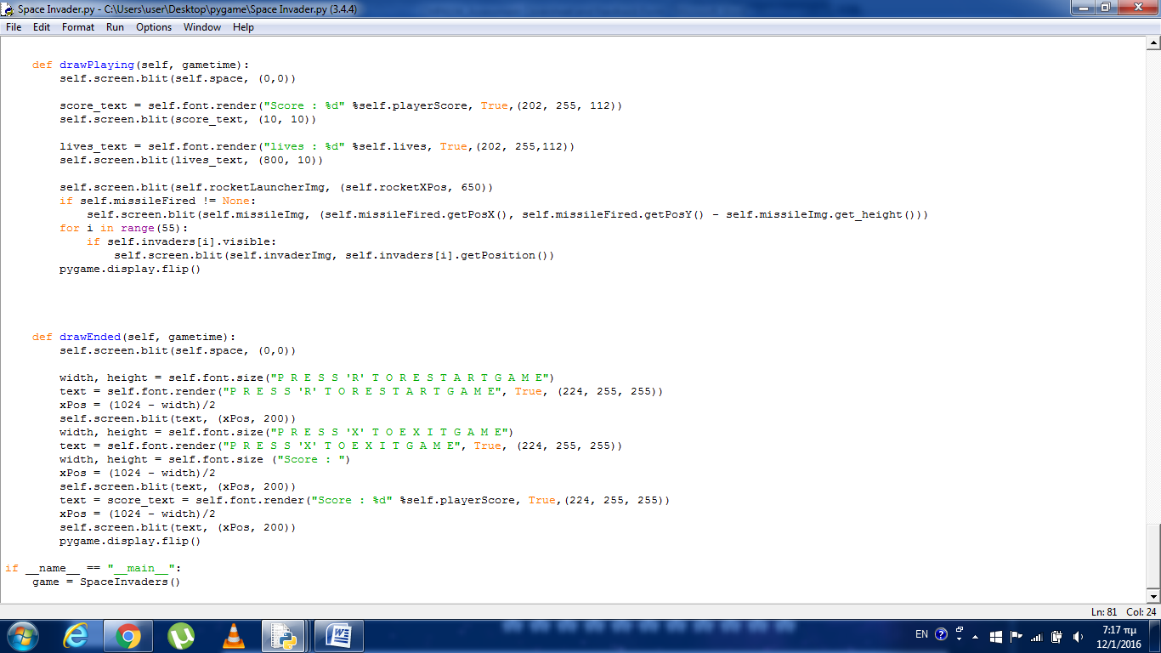

This function shows the page the player will see after he/she win or lose the game. It give you the option to play again or exit the game.